CARIAD SE CPM Project

Functional Specification

Synchronize Project

|  |  |
| --- | --- |
| Person Responsible: | Jimmy Xu |
| Status: | in review |
| Version: | V1.0 |
| Date: | 13/03/2025 |
|  |  |
|  |  |
|  |  |

Version History:

| Version | Date | Author | Comments |
| --- | --- | --- | --- |
| V1.0 | 13/03/2025 | Jimmy Xu |  |
|  |  |  |  |
|  |  |  |  |

# Business Purpose

In CARIAD SE, different objects are created for projects.

* Portfolio Item in PFM.
* Commercial Project in CPM.
* WBS Element in PS.

In standard SAP, CPM projects can be created and synchronized from portfolio item.

To fasten the creation process of WBS Elements, a program is implemented.

Creation:

1. Create WBS Elements
2. Link WBS Elements to CPM projects
3. Create default financial plan

Synchronization:

1. Update WBS attributes
2. Update WBS status
3. Update WBS partners

# Functional Specification

## Overview

Functional requirement: Synchronize project attributes from newly added/changed portfolio items.

**Initial Screen:**

Filter:

Portfolio Item

Radio Button:

Delta from last synchronization.

All projects.

**Prerequisite:**

Synchronization time is logged for each project.

|  |  |
| --- | --- |
| Project ID | Last Synchronization |
| D.10.00034 | 12.03.2025 09:00:35 |

* Portfolio Item

Multi selection. If set empty, read all portfolio items.

* Delta from last synchronization

For input portfolio item, compare last change timestamp on item master data and last synchronization timestamp.

If last change is later than last synchronization, run below logic.

* All Projects

Run below logic for all input portfolio items.

If WBS does not exist. Run Create PS Object.

If WBS already exists. Run Synchronize PS Object.

## Create PS Object

Functional requirement: Automate manual steps on PS objects.

Step 1, Create PS Objects

Functional requirement: New WBS elements should be created under a specified project definition which is created by project type.

Create a maintenance mapping table between CPM project type and PS project definition.

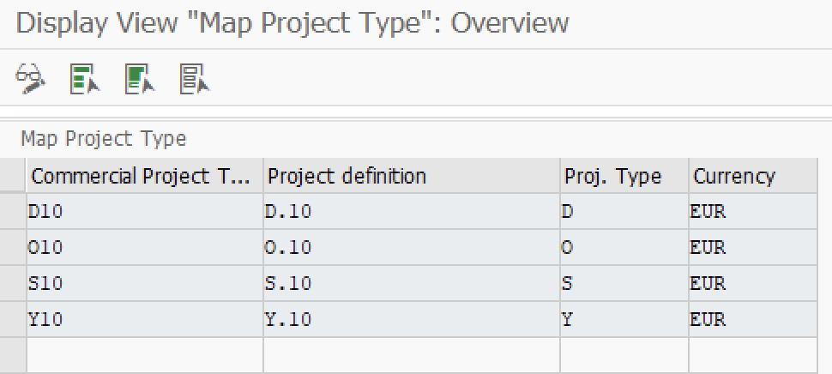

Functional requirement: A two-level WBS hierarchy should be created. 1st level and 2nd level WBS elements should have the same values which are imported from CPM project.

Check if PS objects exists: If there are any WBS ID start with CPM project ID, give warning message: “PS objects already exists.” Jump to next step.

Create WBS element by importing values:

|  |  |
| --- | --- |
| **PS Field** | **Requirement** |
| Project Definition | Based on CPM project type. |
| WBS ID | 1st level WBS element:  Same as CPM project ID.  2nd level WBS element:  = 1st level WBS element + ‘.01’ |
| Responsible Person | Get from Project Manager in portfolio item.  Remove pre-fix “EE”. |
| Company Code | Get from assigned organization in CPM project. |
| Controlling Area | Get from assigned organization in CPM project. |
| Profit Center | Get from portfolio item master data.  ~~Get from Planning Field assigned in CPM project.~~ |
| Project Type | Based on CPM project type. |
| Controlling Area for Requesting CC | Same as Controlling Area |
| Requesting CC | Get from portfolio item master data.  ~~Get from Planning Field assigned in CPM project.~~ |
| Responsible CC | Get from portfolio item master data.  ~~Get from assigned organization in CPM project.~~ |
| Basic Start Date | Get from portfolio item master data |
| Basic End Date | Get from portfolio item master data |
| Planning Element | Mark with flag. |
| External Cooperation | Get from portfolio item master data |
| Cooperation Detail | Get from portfolio item master data |
| Development Status | Get from portfolio item master data |
| Board Name | Get from portfolio item master data |
| Board Date | Get from portfolio item master data |
| Customer Visibility | Get from portfolio item master data |
| Contract Type | Get from portfolio item master data |
| Planning Field | Get from portfolio item master data |
| Sub Planning Field | Get from portfolio item master data |
| Tech Center/ Central Enabler | Get from portfolio item master data |
| Sub System | Get from portfolio item master data |

Functional requirement: For new WBS elements, Partner functions should be created and filled from CPM project team.

In CPM Project Team, get role profile, roles list and member assignment (BP).

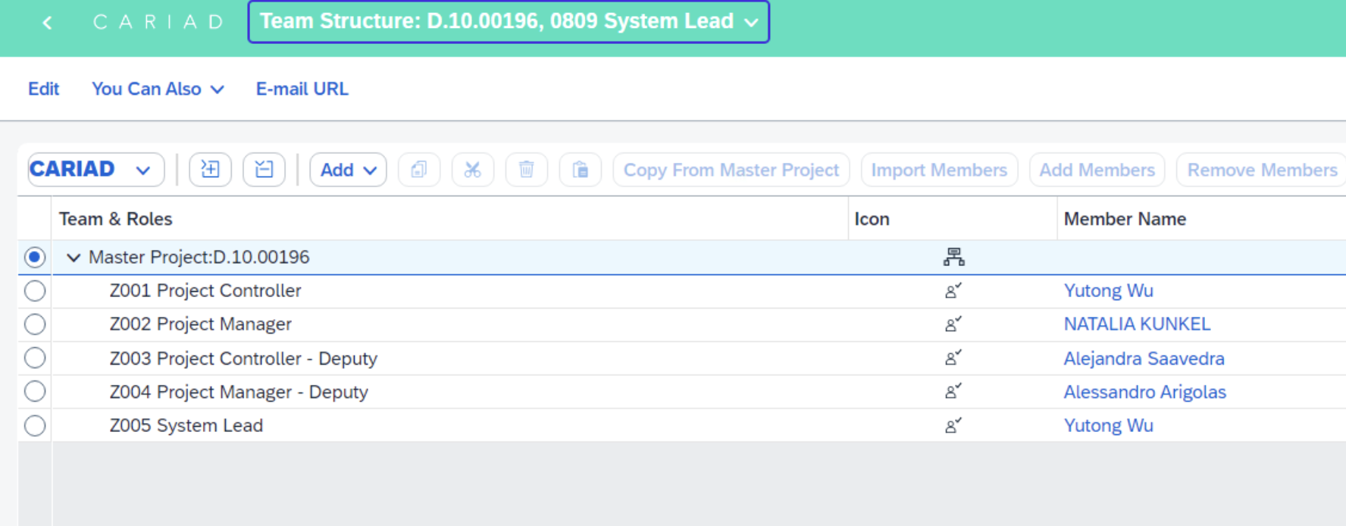

For each role, get mapped Partner Function

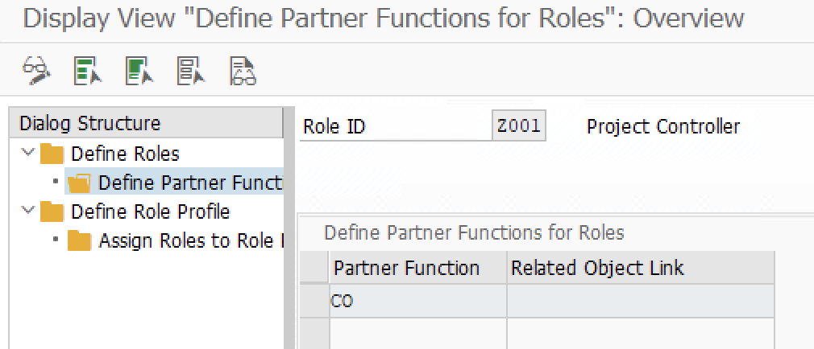

Check partner type defined on Partner Function.

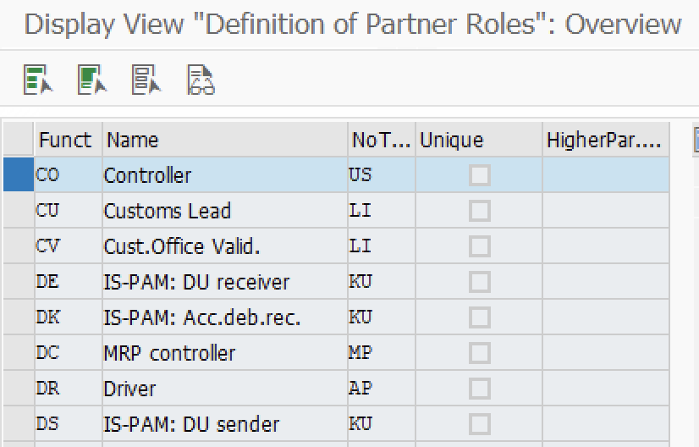

If Partner type = ‘US’, convert member BP to SAP user.

If Partner type = ‘PE’, convert member BP to Personnel Number.

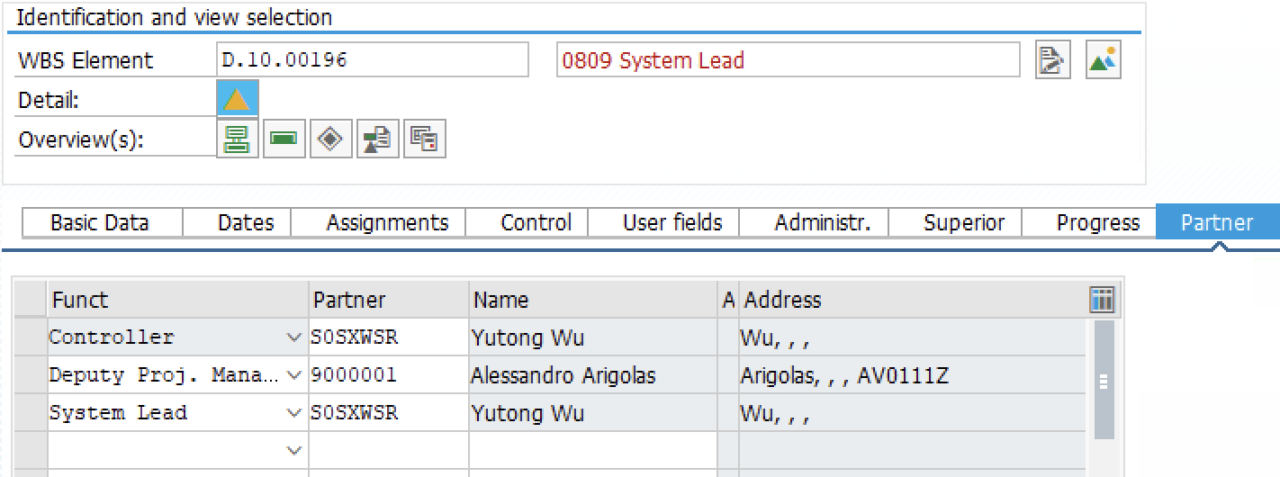

If this step is performed successfully, show message “PS objects are created successfully.”

If error occurs during the creation process, show the error message. Jump to next step.

Step 2, Link PS Objects

Functional requirement: WBS element together with project definition should be linked to CPM project.

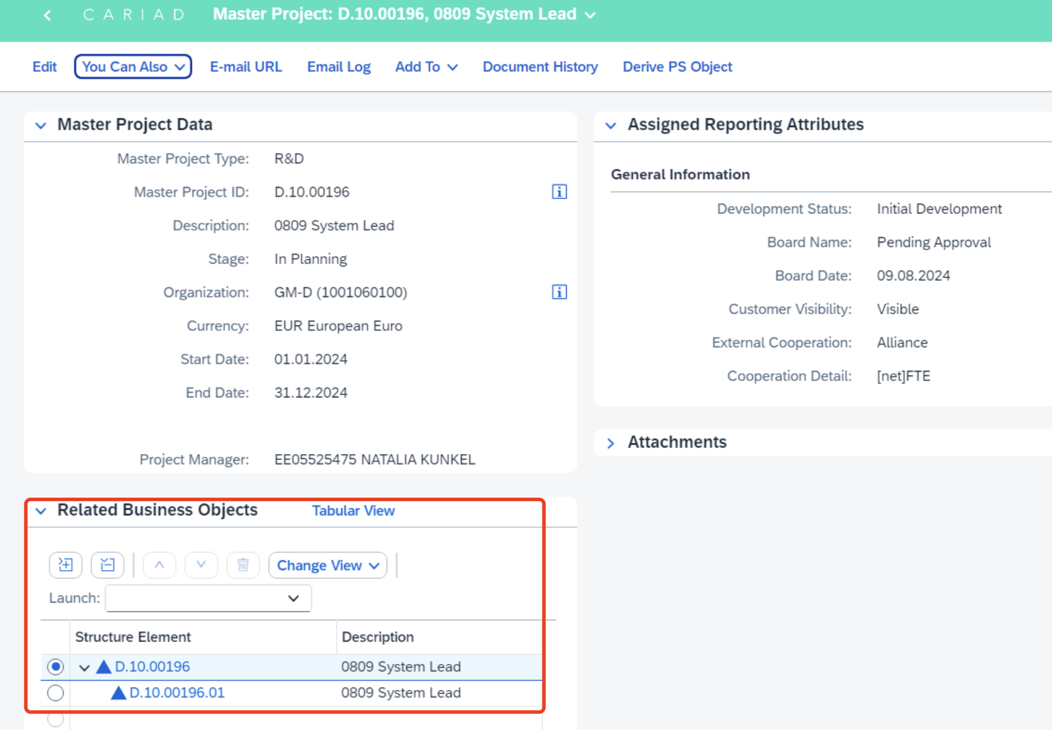

Check if PS objects already assigned: If 1st level WBS element is already assigned to CPM project, give warning message: “PS object is already linked.” Jump to next step.

Create linkages with following object type and object to CPM project.

|  |  |
| --- | --- |
| Object Type | Object |
| ZPD | Relevant Project Definition based on CPM project type. |
| 0WBS | Newly created 1st level WBS. |

If this step is performed successfully, show message “PS objects are linked successfully.”

If error occurs during the creation process, show the error message. Jump to next step.

Step 3, Create Default Financial Plan

Functional requirement: Create financial plan with “Master Project” by default.

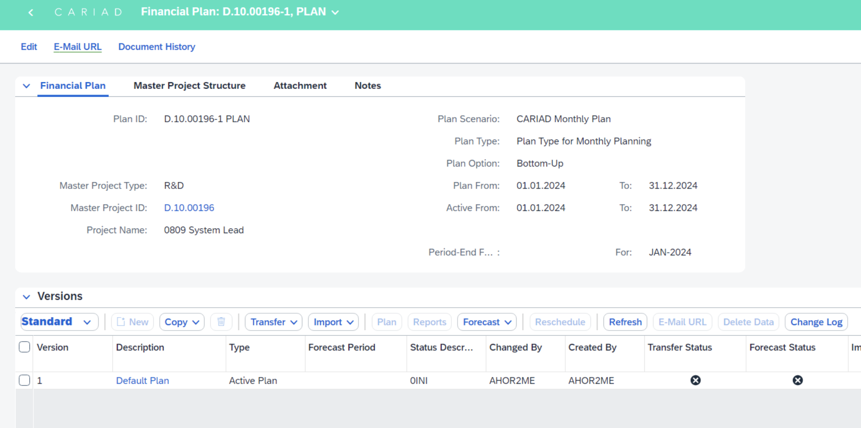

Check if financial plan already exists: If there are financial plan with plan hierarchy set as “Master Project”. Give warning message: “Financial Plan already exists.” Jump to next step.

Create financial plan by importing following values:

|  |  |
| --- | --- |
| **FP Field** | **Requirement** |
| Plan Description | Set “Plan” |
| Plan Scenario | Set “ZPS1” |
| Plan Type | Set “ZPT1” |
| Plan Option | Set “Bottom-Up” |
| Currency | Get from Currency in CPM project. |
| Plan From | Get from Start Date in CPM project. |
| Plan To | Get from End Date in CPM project. |
| Active From | Get from Start Date in CPM project. |
| Active To | Get from End Date in CPM project. |
| Plan Hierarchy | Set “E” Master Project. |
| Version Type | Set “PLAN” |
| Version Description | Set “Default Plan” |

If this step is performed successfully, show message “Financial Plan is created successfully.”

If error occurs during the creation process, show the error message.

## Synchronize PS Object

Functional requirement: Automate synchronize to PS objects.

Step 1, Synchronize Project Attributes

Functional requirement: Attributes on linked WBS elements should be synchronized. 1st level and 2nd level WBS elements should have the same values which are imported from CPM project.

Update WBS element by importing values:

|  |  |
| --- | --- |
| **PS Field** | **Requirement** |
| Project Definition | Based on CPM project type. |
| WBS ID | 1st level WBS element:  Same as CPM project ID.  2nd level WBS element:  = 1st level WBS element + ‘.01’ |
| Responsible Person | Get from Project Manager in portfolio item.  Remove pre-fix “EE”. |
| Company Code | Get from assigned organization in CPM project. |
| Controlling Area | Get from assigned organization in CPM project. |
| Profit Center | Get from portfolio item master data.  ~~Get from Planning Field assigned in CPM project.~~    If errors occur when updating profit center, then only update other fields and skip profit center. |
| Project Type | Based on CPM project type. |
| Controlling Area for Requesting CC | Same as Controlling Area |
| Requesting CC | Get from portfolio item master data.  ~~Get from Planning Field assigned in CPM project.~~ |
| Responsible CC | Get from portfolio item master data.  ~~Get from assigned organization in CPM project.~~ |
| Basic Start Date | Get from portfolio item master data |
| Basic End Date | Get from portfolio item master data |
| Planning Element | Mark with flag. |
| External Cooperation | Get from portfolio item master data |
| Cooperation Detail | Get from portfolio item master data |
| Development Status | Get from portfolio item master data |
| Board Name | Get from portfolio item master data |
| Board Date | Get from portfolio item master data |
| Customer Visibility | Get from portfolio item master data |
| Contract Type | Get from portfolio item master data |
| Planning Field | Get from portfolio item master data |
| Sub Planning Field | Get from portfolio item master data |
| Tech Center/ Central Enabler | Get from portfolio item master data |
| Sub System | Get from portfolio item master data |

Step 2, Synchronize Project Status

Functional requirement: For linked WBS elements, update their status from CPM project.

Create a maintenance mapping table for CPM status change to WBS element status activity.

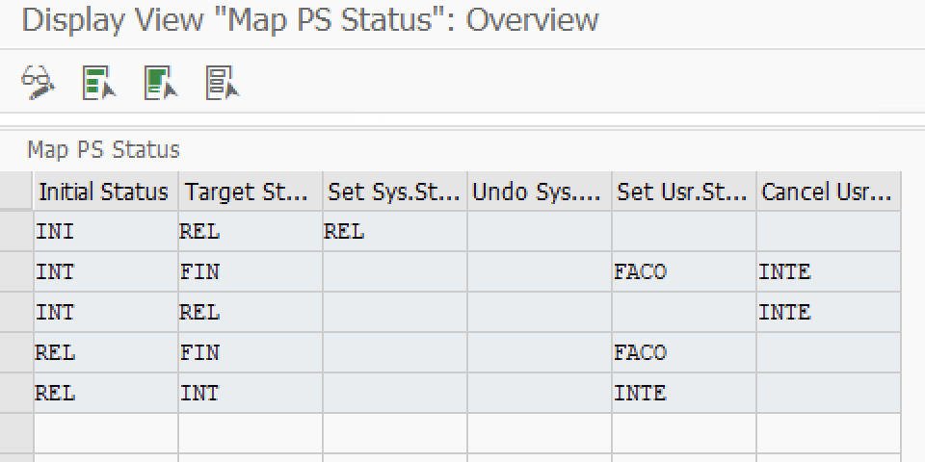

Get status change on project screen, Set/Undo WBS element System/User status according to above mapping table.

|  |  |
| --- | --- |
| **PS Field** | **Requirement** |
| WBS ID | 1st and 2nd level WBS elements |
| Set System Status | From mapping table. |
| Reset System Status | From mapping table. |
| Set User Status | From mapping table. |
| Cancel User Status | From mapping table. |

Step 3, Synchronize Project Team

Functional requirement: For linked WBS elements, Partner functions should be created and filled from CPM project team.

In CPM Project Team, get role profile, roles list and member assignment (BP).



For each role, get mapped Partner Function



Check partner type defined on Partner Function.



If Partner type = ‘US’, convert member BP to SAP user.

If Partner type = ‘PE’, convert member BP to Personnel Number.



# Authorization

NA

# Others